Elton, Gruber, Brown, and Goetzmann
Modern Portfolio Theory and Investment Analysis, 9th Edition
Solutions to Text Problems: Chapter 16

Chapter 16: Problem 1

From the text we know that three points determine a plane. The APT equation for a plane is:
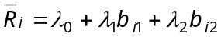

Assuming that the three portfolios given in the problem are in equilibrium (on the plane), then their expected returns are determined by:

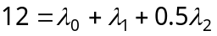 (a)

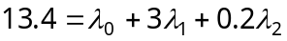 (b)

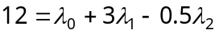 (c)

The above set of linear equations can be solved simultaneously for the three unknown values of λ₀, λ₁ and λ₂. There are many ways to solve a set of simultaneous linear equations. One method is shown below.

Subtract equation (a) from equation (b):
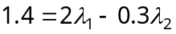 (d)

Subtract equation (a) from equation (c):
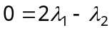 (e)

Subtract equation (e) from equation (d):
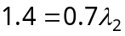 or 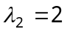

Substitute into equation (d):
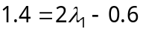 or 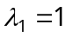

Substitute and into equation (a):
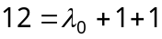 or 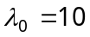

Thus, the equation of the equilibrium APT plane is:

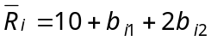

Chapter 16: Problem 2

According to the equilibrium APT plane derived in Problem 1, any security with
b₁ = 2 and b₂ = 0 should have an equilibrium expected return of 12%:

Assuming the derived equilibrium APT plane holds, since portfolio D has b_{D1} = 2 and b_{D2} = 0 with an expected return of 10%, the portfolio is not in equilibrium and an arbitrage opportunity exists.

The first step is to use portfolios in equilibrium to create a replicating equilibrium investment portfolio, call it portfolio E, that has the same factor loadings (risk) as portfolio D. Using the equilibrium portfolios A, B and C in Problem 1 and recalling that an investment portfolio’s weights sum to 1 and that a portfolio’s factor loadings are weighted averages of the individual factor loadings we have:

Simplifying the above two equations, we have:

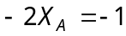 or 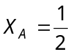

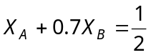

Since , 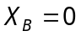 and 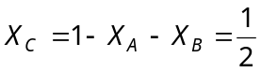.

Since portfolio E was constructed from equilibrium portfolios, portfolio E is also on the equilibrium plane. We have seen above that any security with portfolio E’s factor loadings has an equilibrium expected return of 12%, and that is the expected return of portfolio E:

So now we have two portfolios with exactly the same risk: the target portfolio D and the equilibrium replicating portfolio E. Since they have the same risk (factor loadings), we can create an arbitrage portfolio, combining the two portfolios by going long in one and shorting the other. This will create a self-financing (zero net investment) portfolio with zero risk: an arbitrage portfolio.
In equilibrium, an arbitrage portfolio has an expected return of zero, but since portfolio D is not in equilibrium, neither is the arbitrage portfolio containing D and E, and an arbitrage profit may be made. We need to short sell either portfolio D or E and go long in the other. The question is: which portfolio do we short and which do we go long in? Since both portfolios have the same risk and since portfolio E has a higher expected return than portfolio D, we want to go long in E and short D; in other words, we want 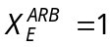 and 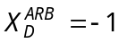. This gives us:

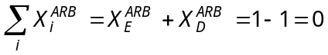 (zero net investment)

But since portfolio E consists of a weighted average of portfolios A, B and C, is the same thing as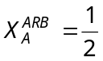, 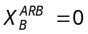 and 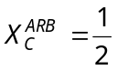, so we have:

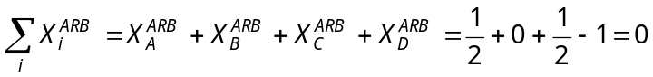 (zero net investment)

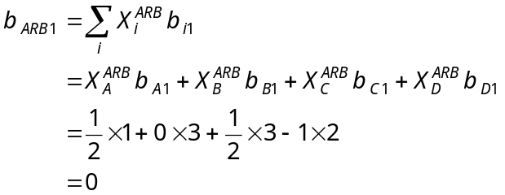 (zero factor 1 risk)

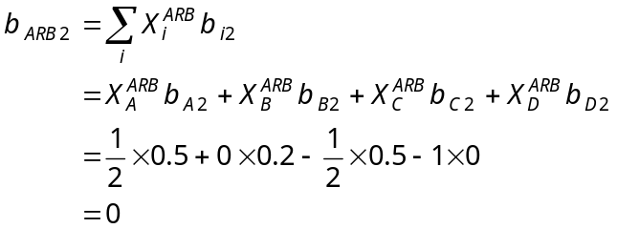 (zero factor 2 risk)

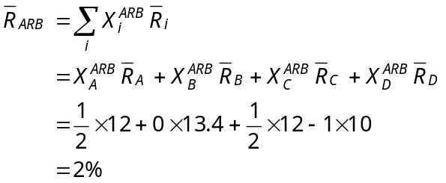 (positive arbitrage return)

As arbitrageurs exploit the opportunity by short selling portfolio D, the price of portfolio D will drop, thereby pushing portfolio D’s expected return up until it reaches its equilibrium level of 12%, at which point the expected return on the arbitrage portfolio will equal 0. There is no reason to expect any price effects on portfolios A, B and C, since the arbitrage with portfolio D can be accomplished using other assets on the equilibrium APT plane.
Chapter 16: Problem 3

From the text we know that three points determine a plane. The APT equation for a plane is:

Assuming that the three portfolios given in the problem are in equilibrium (on the plane), then their expected returns are determined by:

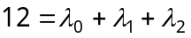 (a)

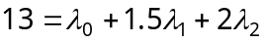 (b)

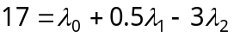 (c)

Solving for the three unknowns in the same way as in Problem 1, we obtain the following solution to the above set of simultaneous linear equations:

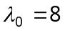; 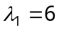; 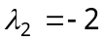;

Thus, the equation of the equilibrium APT plane is:

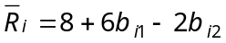

Chapter 16: Problem 4

According to the equilibrium APT plane derived in Problem 3, any security with
b₁ = 1 and b₂ = 0 should have an equilibrium expected return of 12%:

Assuming the derived equilibrium APT plane holds, since portfolio D has b_{D1} = 1 and b_{D2} = 0 with an expected return of 15%, the portfolio is not in equilibrium and an arbitrage opportunity exists.

The first step is to use portfolios in equilibrium to create a replicating equilibrium investment portfolio, call it portfolio E, that has the same factor loadings (risk) as portfolio D. Using the equilibrium portfolios A, B and C in Problem 3 and recalling that an investment portfolio’s weights sum to 1 and that a portfolio’s factor loadings are weighted averages of the individual factor loadings we have:

Simplifying the above two equations, we have:

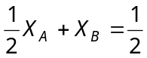

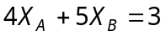

Solving the above two simultaneous equations we have:

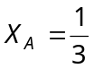, 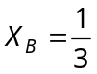 and 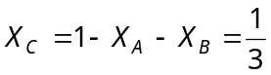.

Since portfolio E was constructed from equilibrium portfolios, portfolio E is also on the equilibrium plane. We have seen above that any security with portfolio E’s factor loadings has an equilibrium expected return of 14%, and that is the expected return of portfolio E:

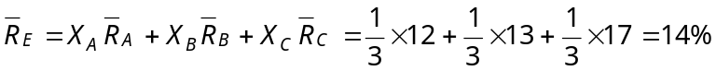

So now we have two portfolios with exactly the same risk: the target portfolio D and the equilibrium replicating portfolio E. Since they have the same risk (factor loadings), we can create an arbitrage portfolio, combining the two portfolios by going long in one and shorting the other. This will create a self-financing (zero net investment) portfolio with zero risk: an arbitrage portfolio. In equilibrium, an arbitrage portfolio has an expected return of zero, but since portfolio D is not in equilibrium, neither is the arbitrage portfolio containing D and E, and an arbitrage profit may be made.

We need to short sell either portfolio D or E and go long in the other. The question is: which portfolio do we short and which do we go long in? Since both portfolios have the same risk and since portfolio D has a higher expected return than portfolio E, we want to go long in D and short E; in other words, we want 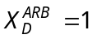 and 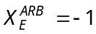. This gives us:

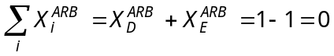 (zero net investment)

But since portfolio E consists of a weighted average of portfolios A, B and C, is the same thing as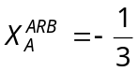, 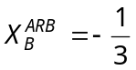 and 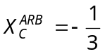, so we have:

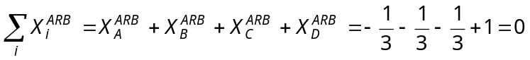 (zero net investment)

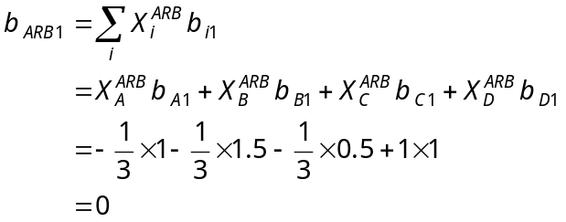 (zero factor 1 risk)

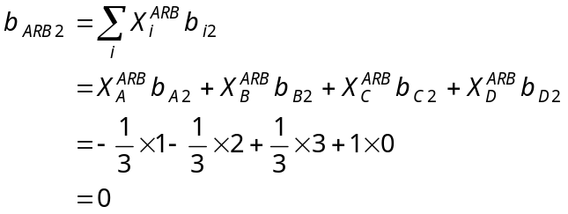 (zero factor 2 risk)

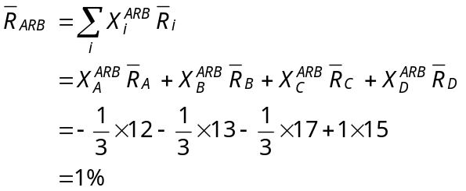 (positive arbitrage return)

As arbitrageurs exploit the opportunity by buying portfolio D, the price of portfolio D will rise, thereby pushing portfolio D’s expected return down until it reaches its equilibrium level of 14%, at which point the expected return on the arbitrage portfolio will equal 0. There is no reason to expect any price effects on portfolios A, B and C, since the arbitrage with portfolio D can be accomplished using other assets on the equilibrium APT plane.

Chapter 16: Problem 5

The general K-factor APT equation for expected return is:

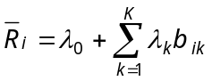
where λ₀ is the return on the riskless asset, if it exists.

Given the data in the problem and in Table 16.1 in the text, along with a riskless rate of 8%, the Sharpe multi-factor model for the expected return on a stock in the construction industry is:

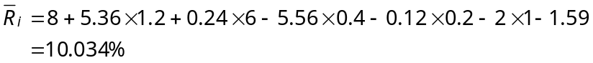

The last number, −1.59, enters because the stock is a construction stock.

Chapter 16: Problem 6

A.
From the text we know that, for a 2-factor APT model to be consistent with the standard CAPM, 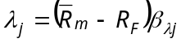. Given that 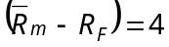 and using results from Problem 1, we have:

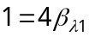 or 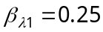; 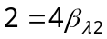 or 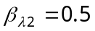.
B.
From the text we know that 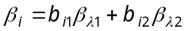. So we have:

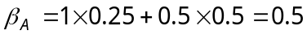

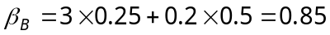

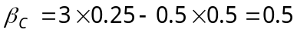

C.
Assuming all three portfolios in Problem 1 are in equilibrium, then we can use any one of them to find the risk-free rate. For example, using portfolio A gives:

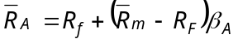 or 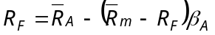

Given that 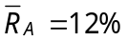, 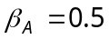and 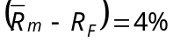, we have:

